**LETSUPGRADE- JavaScript Essentials Program- Assignment Day 2**

**(Srishti Rakesh Pandey)**

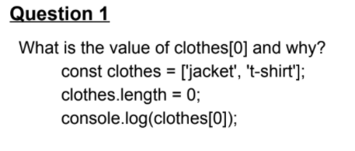

**Solution**

// Srishti Rakesh Pandey

// LetsUpgrade Javascript Essentials Assignment 2

// Question 1

// Q1) What is the value of clothes[0] and why?

const clothes = ['jacket', 't-shirt'];

clothes.length = 0;

console.log(clothes[0]);

// var arr=["jacket", "t-shirt"];

// console.log(arr[0]);

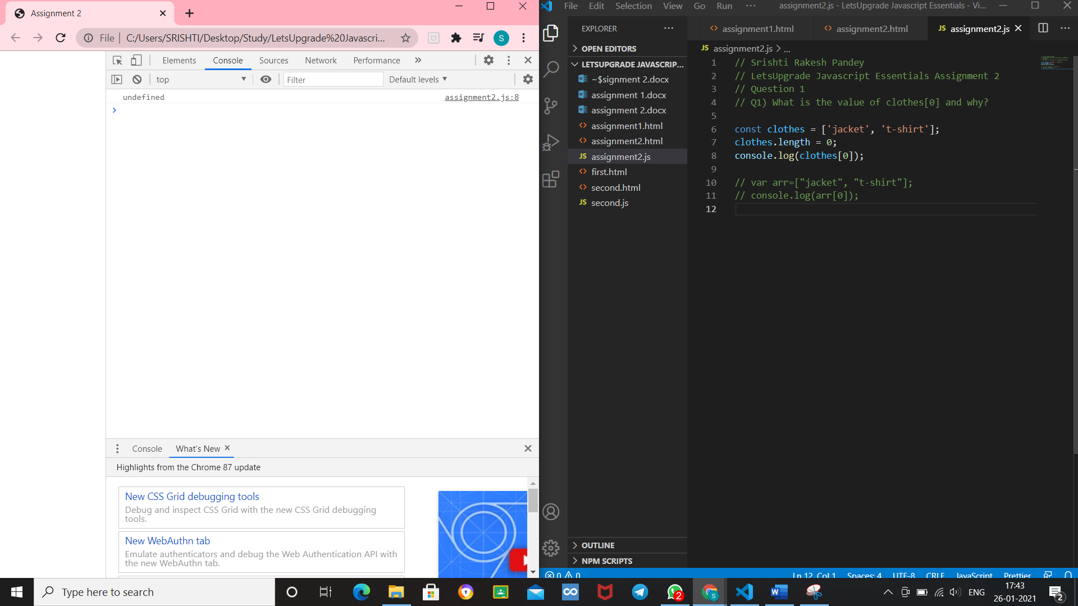

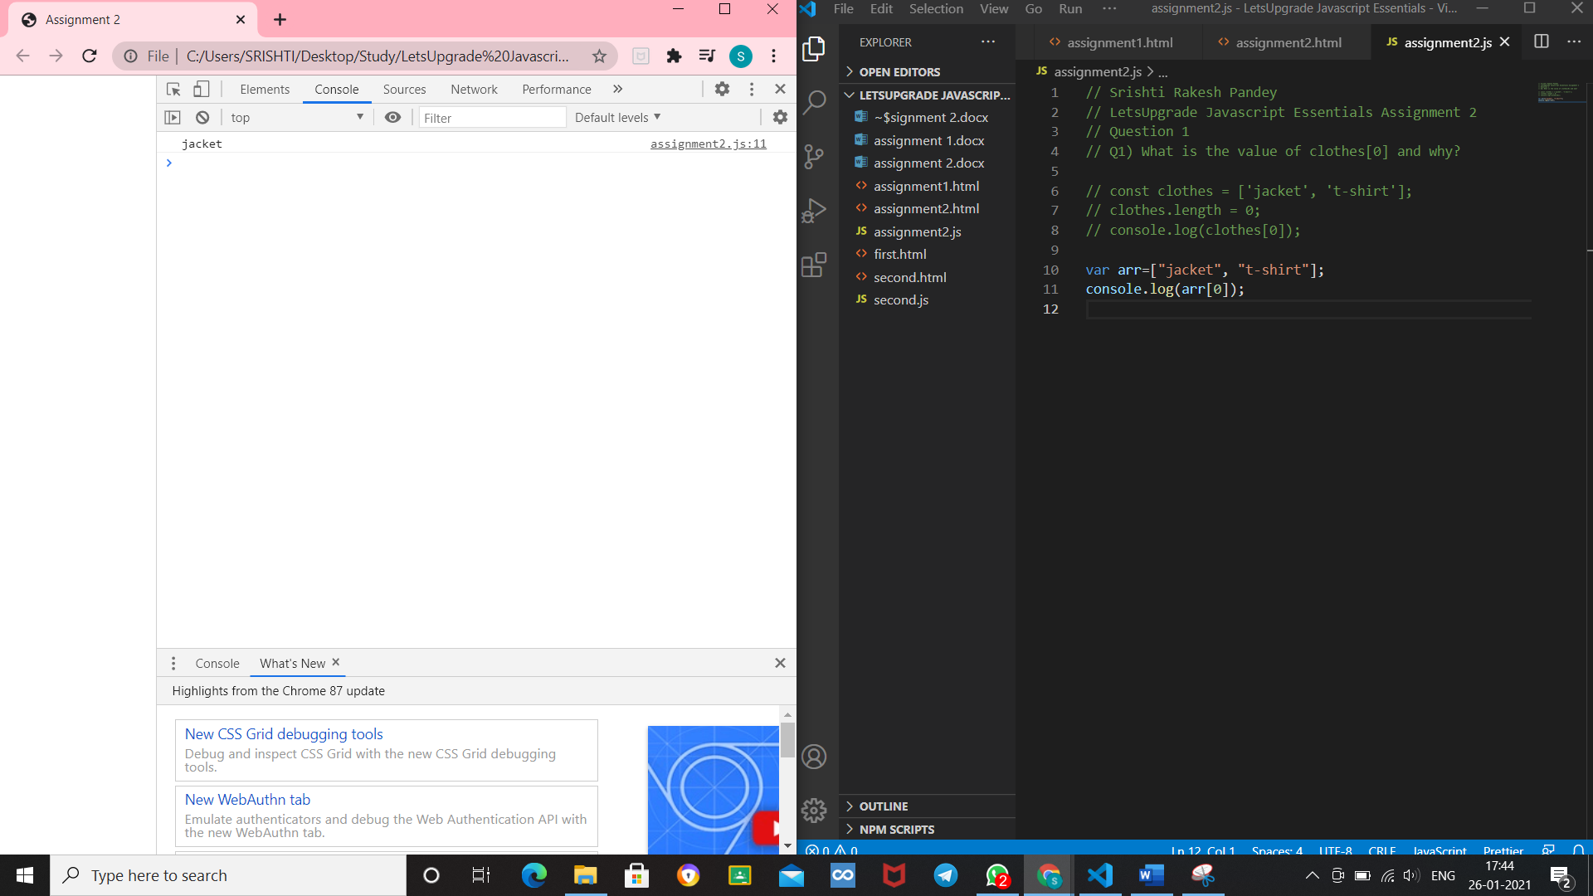

The value is undefined as we the length is incorrectly defined in the question, as well as const is used for the array.

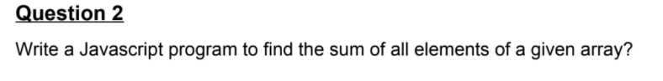

**Solution**

// Q2) Write a Javascript program to find the sum of all elements of a given array?

var array = [1, 2, 3, 4, 5, 6],

    sum = 0,

    i;

for (i = 0; i < array.length; i += 1)

   {

    sum += array[i];

}

console.log("The sum is:" +sum);

